**Project Name : EcoScan**

**Team ID : C23-PR526**

**Team Member :**

* **(ML) M350DSY1435 – Hajarani Syadzwana – Universitas Sumatera Utara - [Active]**
* **(ML) M350DSX1794 – Muhammad Iqbal Aldeena – Universitas Sumatera Utara - [Active]**
* **(ML) M125DKY4655 – Azilla Auri Pramesti – UIN Syarif Hidayatullah Jakarta - [Active]**
* **(CC) C350DSX1608 – T.M. Rezha Taufiqurrahman, Mx – Universitas Sumatera Utara - [Active]**
* **(CC) C058DKX4155 – Afdan Syukron – Politeknik Negeri Banyuwangi - [Active]**
* **(MD) A034DKX4179 – Putra Cendikia Subekti – Institut Teknologi Kalimantan - [Active]**

**Project Schedule (based on project plan):**

| **5 May 2023 - 12 May 2023** |
| --- |
| Looking for ideas, looking for data and references, collecting proposals, waiting for announcements. create wireframes |

| **13 May 2023 - 19 May 2023** |
| --- |
| Revise the project, explore the tools to be used, learn more about the unknown, change things that need to be revised and find solutions for even better projects. Get the results of the last project plan announcement and continue the work that has been done before,  ML:  -data collection  -data cleaning  - try to find best model  CC:  - Developing API  - Building a landing page  MD:  - Design (Flow and UI Application)  - Implement design to UI application |

| **20 May 2023 - 26 May 2023** |
| --- |
| Consult with mentors and discuss problems encountered  ML:  - Feature selection  -choose the most probable model  -implement models  - Test the model  - evaluated model  CC:  - Deploying API  - Create a simple website for testing  - Giving API to the MD  MD:  - Implement design to UI application  - Build Features that doesn’t need API |

| **27 May 2023 - 31 May 2023** |
| --- |
| 31 May report the progress  ML:  additional evaluation and fixing what can be improved from the model  CC:  -Create a Data Generator  MD:  - Build Features that need API  - Build APK |

**Project Progress Description:**

* **Progress/task has been completed**

| **Machine Learning** | **Cloud Computing** | **Android** |
| --- | --- | --- |
| Collect image data from each object needed such as refrigerators, lamp, oven. | Landing Page for the Application. | Make design of the application in figma |
| Collect power data for household appliances |  | Slicing of the design that was made, has made slicing that can access the camera and open images from the gallery |
| try training data with a simple model |  |  |

* **Progress/task on progress**

| **Machine Learning** | **Cloud Computing** | **Android** |
| --- | --- | --- |
| Preprocessing data and try on a good model and find the right one moreover we are trying to make multiclass classification | API Development. | Implementation design that not finished |
| training data with other models that are better and more suitable and more complex to to reduce overvitiing | Creating a Data Generator | Build Every Navigation on UI Android |

* **Progress/task not started**

| **Machine Learning** | **Cloud Computing** | **Android** |
| --- | --- | --- |
| Determine the appropriate model, image training, model deployment | API Deployment. | Consuming API |
|  | Giving API to Mobile Development. | Build Local Storage |

**If the complete capstone is 100%, tell us how many percent of your group's project has been completed? Please describe the reason for your percentage.**

As of now, we would say 30% of the project is done. Machine Learning path has almost completed the dataset and will soon start building the model for the app. Meanwhile the Mobile Development team has started slicing and making designs for the UI of the app. The Cloud Computing team has started making API Development and Data Generator as a backup. The CC team also made a Landing Page for the Application.

**Please attach your supporting evidence.**

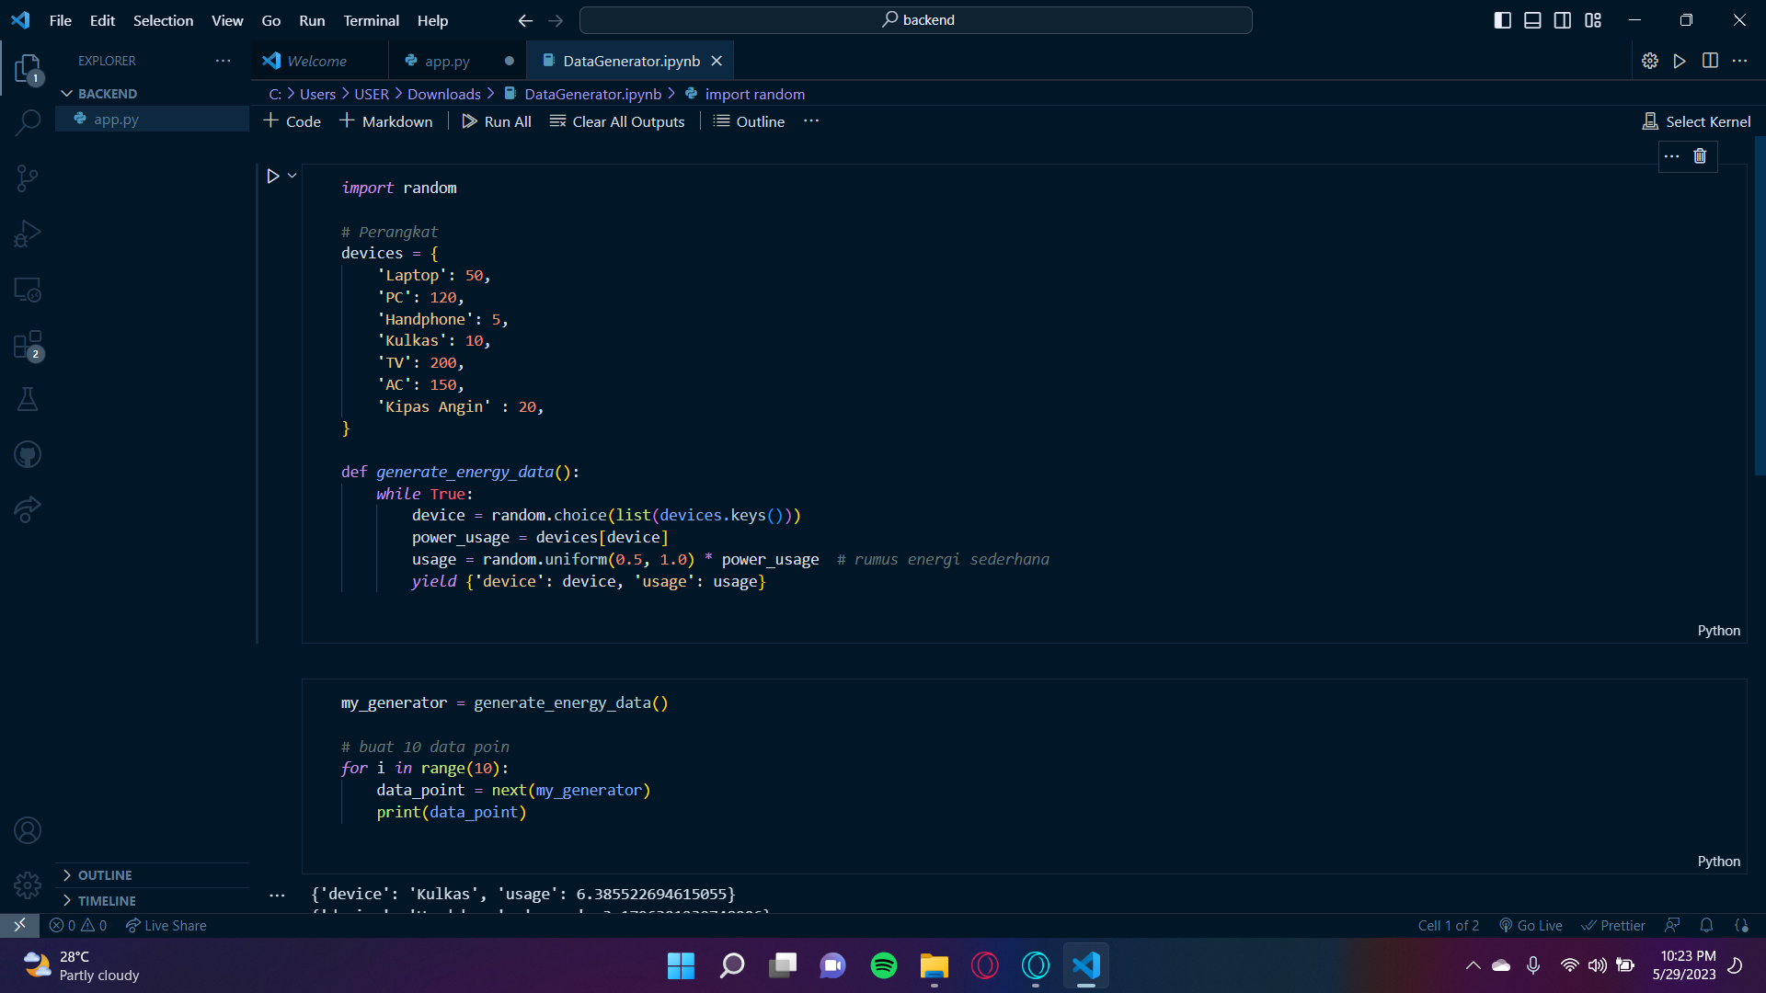

Data Generator oleh CC Team

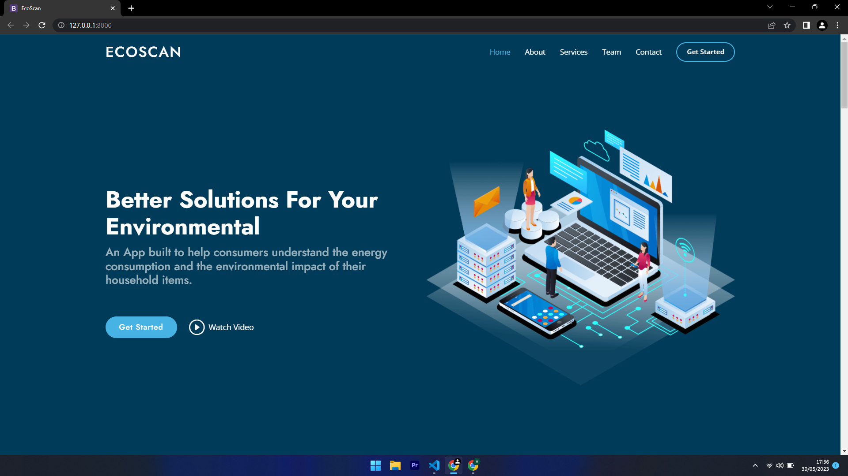

Tampilan Landing Page oleh Team CC

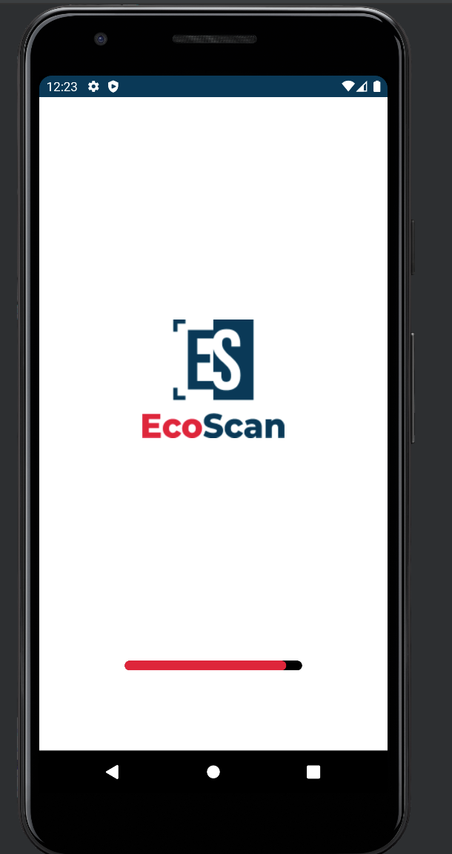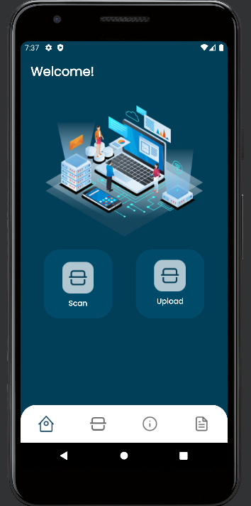

Splash Screen and Home Screen by Mobile Developer

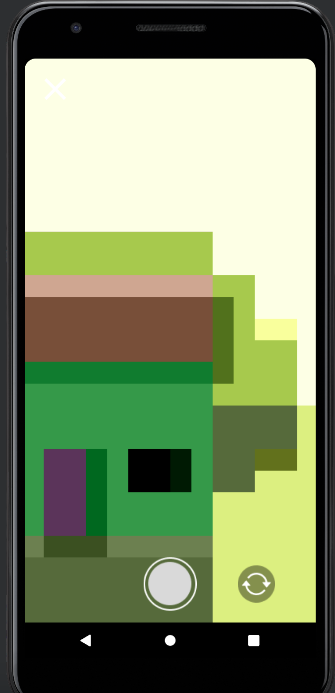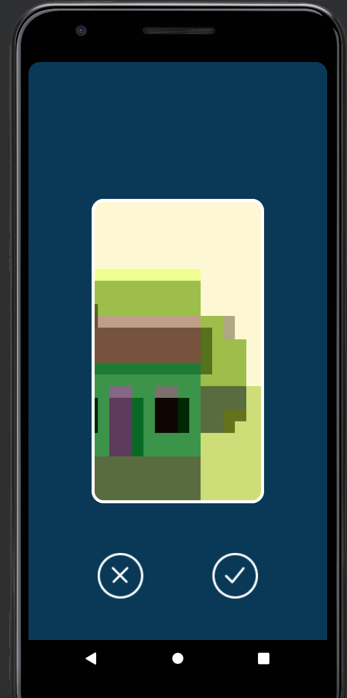

CameraX and Preview Screen by Mobile Developer

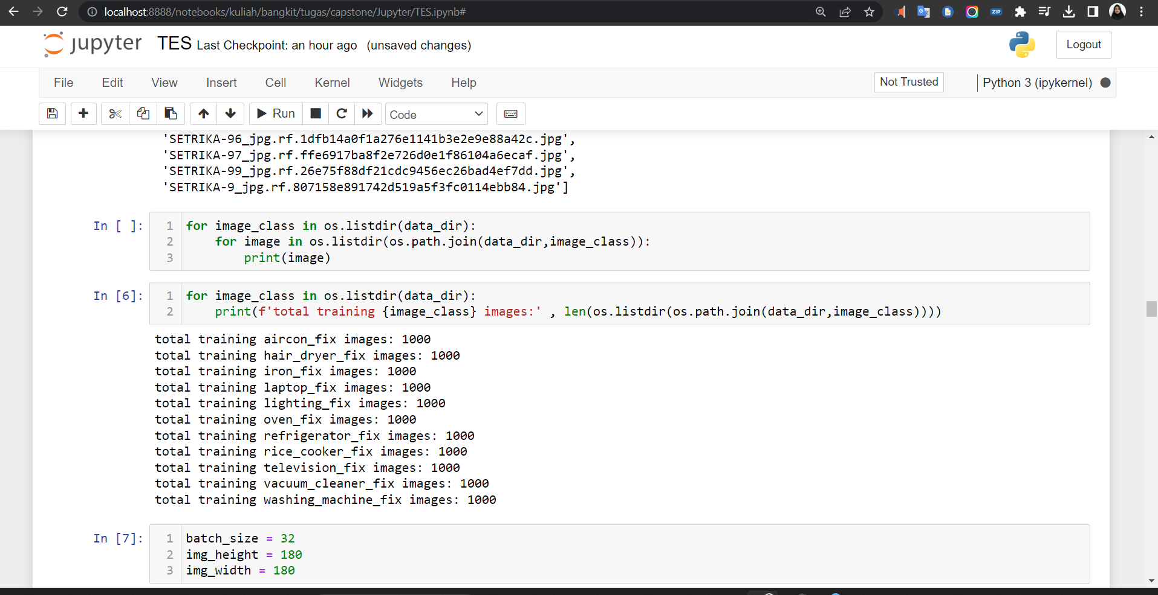

amount of training data by Machine Learning

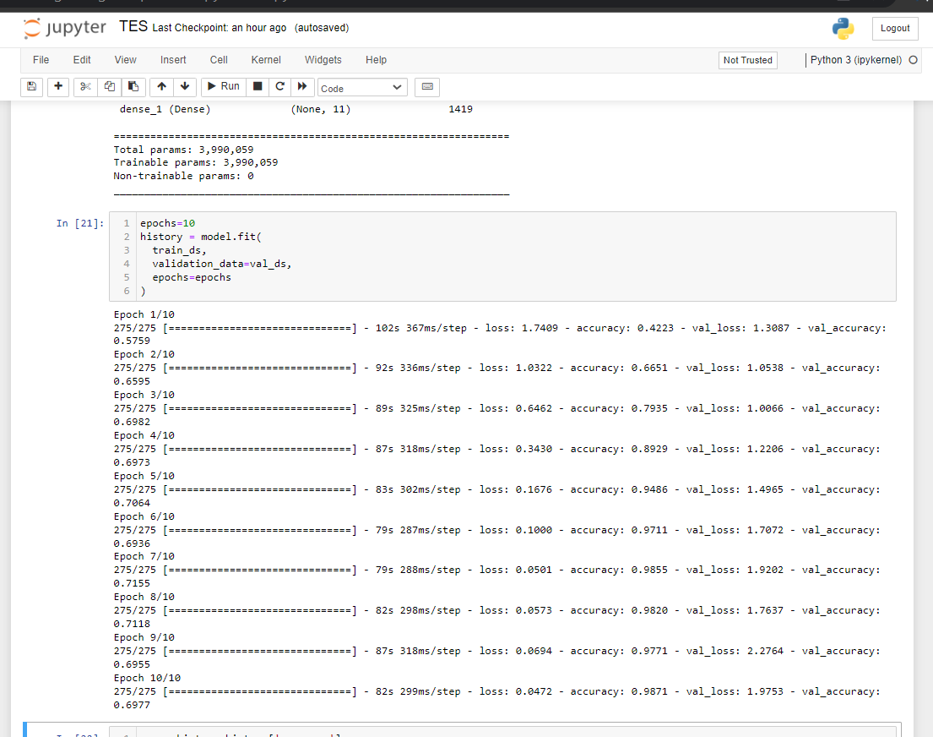

current training results by Machine Learning

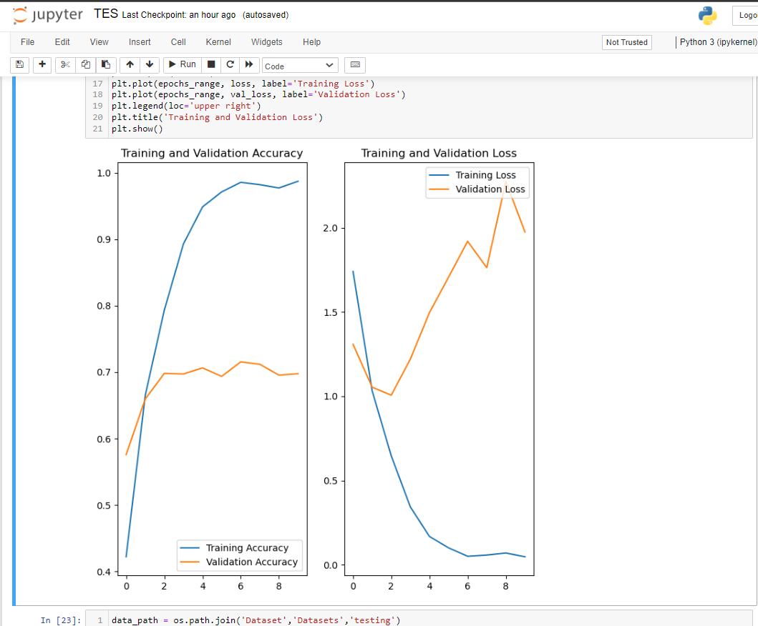

chart to see overfitting by Machine Learning

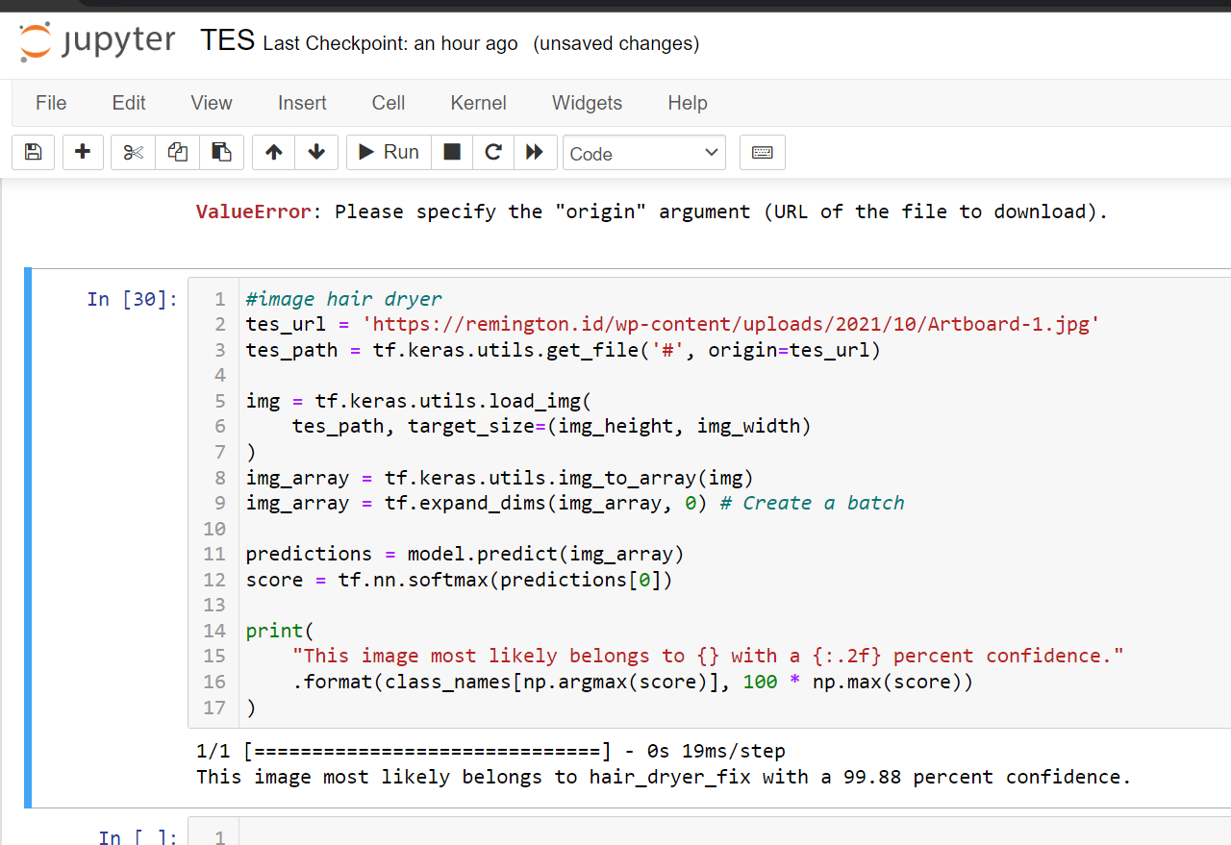

current predictive results by Machine Learning